Membership Application

Native Women’s Collective

2013
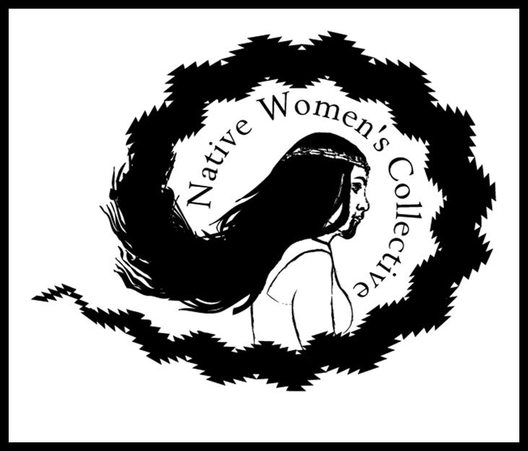

Applicant Information
Full Name: |  |  |  |  |  | Date:
Last |  | First |  |  | M.I.
Address:
Street Address |  |  |  |  | Apartment/Unit #
City |  |  |  |  | State |  | ZIP Code
Phone: | ( ) |  | E-mail Address:
SSN: | - - |  | Website:

If you are interested in being a registered artist/ consultant with the NWC please fill out sections B-D of this application. If not, please skip to section E.
- Individual Artist/ Consulting Rates
From time to time the Native Women’s Collective may call upon artists and/or consultants who are members of the organization for projects/ programs and/or services. If you are an artist or consultant interested in working with the Native Women’s Collective please let us know more about you and your services below.
Rate Per Hour: |  |  | Rate Per Day.: $ |  |  |  |  |  | Per Project: | $
 |  |  | Are rates negotiable?
Are you a citizen of the United States? |  |  |  | YES | NO |  |  | If no, are you authorized to work in the U.S.? |  |  | YES |  | NO
Have you ever been convicted of a felony? |  |  |  | YES | NO |  |  | Are you an enrolled member of a federally recognized tribe? |  |  |  | YES |  | NO
If yes, explain: | Tribal Affiliation:

Artist/ Consultant Prioritized Services (Top 3 Services Offered)
1:
2:
3:

Description of Any Other Services Offered
Please include an electronic copy of your Resume/ CV, pictures, audio files, film clips, or other information you would like to include in your portfolio.

Membership Statement
Please tell us why you are interested in becoming a member of the Native Women’s Collective, how you are interested in participating in the organization and what you hope to get from the organization.

- Native Women’s Collective Services Survey
The Native Women’s Collective offers and will be offering a number of services to their consultants and/or artists so that they can better serve the community. Please answer the questions below.
Would you pay for a membership to the NWC? |  | YES | NO | What is the range of $ you would be willing to pay for membership?
What are some membership benefits you would like to see offered? (Check all that apply) |  | Referrals |  | Retail Discount | Free Workshops | Project Development
Marketing To Agencies | Finding Work Opportunities | Fellowships |  | Listing on Website | Conference Attendance | Career Development
Office/ Retail/ Work Space | Referrals to Clients | Events |  | Page on Website | Think Tank/ Round Table | Lectures/ Guest Speaker
Would you like the NWC to include a page about you on our website? |  | YES | NO

- Memberships
The Native Women’s Collective is a nonprofit organization supported by donations, public funding and memberships. Our memberships provide a wide range of services for our members. MORE BENEFITS may be added as we grow as an organization. At this time the Native Women’s Collective is offering Affiliated Memberships (Native American descent) or Friends of the NWC (Non Native) memberships (descriptions below). Memberships begin on January 1 (or date thereafter on which you complete the form) and end December 31 of each year. Registered members will receive an email asking for confirmation of continued interest of retaining their membership affiliation during December of each year. Affiliated memberships and Friends of the NWC memberships may be cancelled at any time by the NWC or member by written statement.

Which membership option will you be signing up for today?

I agree to meet the membership guidelines and understand that I am responsible for renewing membership each year. I understand that I am not a member of the NWC until my application has been approved by the NWC Executive Director. I understand that in order to cancel my membership I must provide a written statement to the NWC. I understand that the NWC reserves the right to cancel my membership at any time.

Date: Signature: ________________________________________________________________________

Date Approved: Signature: ________________________________________________________________

Membership Descriptions:
Friends of the NWC (Non Native)

Discounts at NWC Workshops*
Newsletter subscription
Discounts to NWC events
Priority registration at NWC Workshops & Events
Eligibility for yearly art drawing at Holiday Event.
Eligibilty to serve as Board Member if elected.

*all items made for and/or at NWC workshops, events or gatherings are property of the NWC unless otherwise explicitly agreed upon.

Affiliated Membership (Native American)
Must be a member of a federally recognized tribe, a descendent of a federally or state recognized tribe, or a descendent of a historically recognized tribal group.

Consign and/or sales of items at NWC tables/ events/ retail space
Free Attendance at NWC Workshops
Priority registration at NWC Workshops & Events
Newsletter Subscription
Eligibility to serve as Board Member if elected.

Items consigned with the NWC will be charged 15% of the total sold as a donation to the NWC for operating costs.

*all items made for and/or at NWC workshops, events or gatherings are property of the NWC unless otherwise explicitly agreed upon.

